|  |
| --- |
| **[cloud computing]** |
|  |

Practical: 10

Salesforce (CRM)

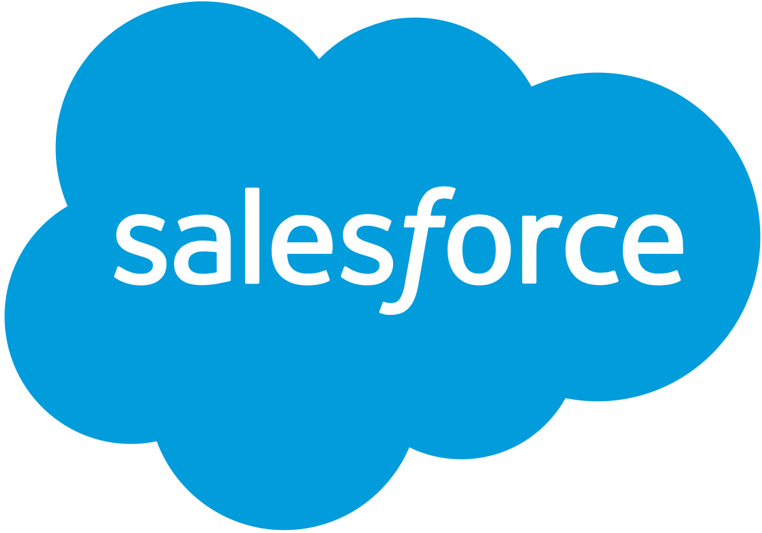

Submitted By: Samip Shah

Enrollment No: 15012011045



**GANPAT UNIVERSITY**

**U. V. Patel College of Engineering**

**Computer Engineering Department**

Salesforce is a cloud computing company which offers a variety of services (SaaS) and products (PaaS). Salesforce started as Software as a Service (SAAS) CRM company.

* Salesforce is the innovative company behind the world’s #1 CRM platform. Their software is cloud-based, so it doesn’t require a team of IT experts to set up or manage — you just log in and start using it.
* It was founded in 1999 by former Oracle executive Marc Benioff, Parker Harris, Dave Moellenhoff, and Frank Dominguez - with a vision to reinvent the Cloud CRM model.
* In simple language. Salesforce is a tool, which helps people, manages their database in a very interesting and easy to use interface. In order to make it more efficient Salesforce has added more functionality to manage your complex automations in daily activities of a business process. It is not just a Customer Relationship Management Tool; it provides us Software, Platform and Infrastructure as a service.

**What is Salesforce CRM (Customer Relationship Management) ?**

It’s software that stores customer contact information like names, addresses, and phone numbers, as well as keeps track of customer activity like website visits, phone calls, email, and more.

**On Premise vs Cloud-based CRM**

* CRM software solutions were offered in an on-premise delivery model until a few years ago.
* Companies installed the software on their servers and maintained it in-house.
* With the on-premise CRM, IT companies had to take on the technical responsibilities, which include system design, infrastructure and server management.
* In any cloud based CRM, the vendor hosts applications and organizations can gain access to data through the web.
* No worries about any technical aspects of managing it.
* Cloud CRM has become popular over time because:
  + There was no software-licensing fee involved.
  + The organization did not need dedicated IT staff or infrastructure.
  + Reduced the cost of monthly services and eased the set up process.

**Cloud Services Offered by Salesforce**

It was developed to make organizations function efficiently and profitably by reducing the cost of managing hardware infrastructure.

The cloud services that are offered by Salesforce are:

* **Salesforce Sales Cloud**

The Sales Cloud is a CRM platform that enables you to manage your organization’s sales, marketing and customer support facets. If your company is engaged in business-to-business (B2B) and business-to-customer (B2C), then sales cloud is the service your sales team needs.

* **Salesforce Marketing Cloud**

The marketing cloud provides you with one of the world’s most powerful digital marketing platforms. The marketers in your organisation can use it to manage customer journey, email, mobile, social media, web personalization, content creation, content management and data analytics.

* **Salesforce Service Cloud**

The Service Cloud is a service platform for your organization’s customer service and support team. It provides features like case tracking and social networking plug-in for conversation and analytics. This not only helps your agents to solve customer problems faster, but also gives your customers access to answers. Using these answers your customers can solve problems on their own.

* **Salesforce Community Cloud**

If you need a social platform for your organization to connect and facilitate communication among your employees, partners and customers then Salesforce Community Cloud is the service you need. You can use this platform to exchange data and images in real time.

* **Salesforce Commerce Cloud**

The commerce cloud enables your organization to provide seamless customer service and experience irrespective of  your customer’s location (online or in-store). It also provides for customer data integration so that your consumers can have a better experience. If your goal is to provide customer with a positive, engaging customer experience, Commerce Cloud is the service you need.

* **Salesforce Analytics Cloud**

The Analytics Cloud provides a business intelligence platform for your organization to work with large data files, create graphs, charts and other pictorial representations of data. It is optimized for mobile access and data visualization and can be integrated with other Salesforce clouds.

* **Salesforce IoT Cloud**

When your organization needs to store and process Internet of Things (IoT) data, you can utilize the service of Salesforce IoT cloud. The platform is built to take in massive volumes of data generated by devices, sensors, websites, applications, customers and partners. On receiving this data, the platform initiates actions to give you real time responses.

* **Salesforce Health Cloud**

If you are a Health IT organization and require a CRM system that incorporates doctor-patient relationship and record management, then Health Cloud is what you need. Through the patient profile you can support one-to-one relationship by integrating information from multiple data sources.

* **Salesforce App Cloud**

To develop custom apps that will run on the Salesforce platform, you can use the Salesforce App Cloud. It provides you with a collection of development tools that you can utilize to create custom applications.

* **Chatter**

Chatter is an enterprise collaboration platform from Salesforce that enables your employees to collaborate. Chatter can help you drive productivity by connecting employees wherever they are. It also helps in knowledge sharing between departments in an organization or different organizations.

* **Salesforce1**

Salesforce1 is the platform which enables you to develop application and exchange data via Application Programming Interface (APIs). APIs refer to prebuilt programming code components.

**Tools in the App Cloud**

**Force.com :** allows admins and developers to create websites and applications into the main Salesforce.com application.

**AppExchange :** an online application marketplace for third-party applications that run on the Force.com platform.

**Heroku Enterprise :** gives developers the flexibility to create apps using their preferred languages and tools.

**Salesforce Thunder :** big data and rules processing engine designed to analyze events and take personalized actions.

**Salesforce Sandbox :** allows developers to test ideas in a safe and isolated development environment.

**Architecture**

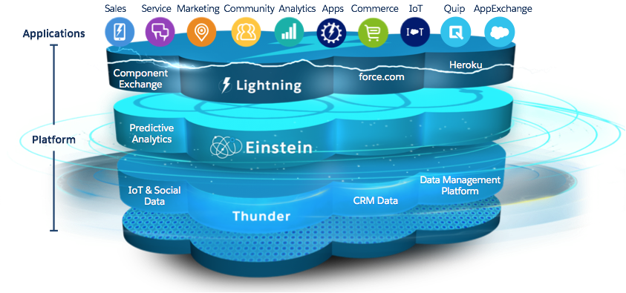

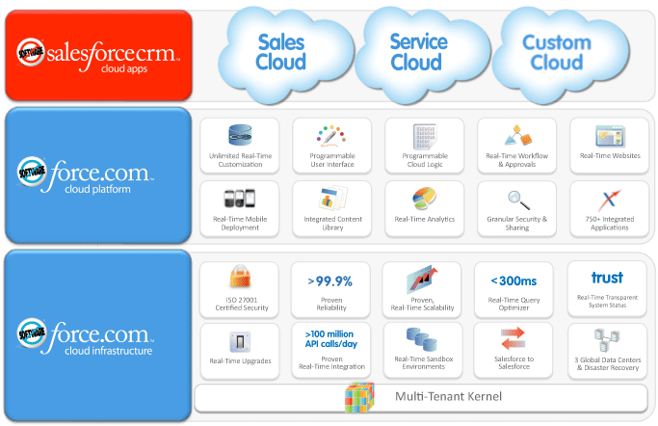

**Technology :**

* [Apex](http://searchsalesforce.techtarget.com/definition/Apex) is a programming language that allows developers to execute flow and transaction control statements on the Force.com platform. As a language, Apex is integrated, easy to use, data-focused, rigorous, hosted, multitenant aware, automatically upgradeable, easy to test, and versioned.
* [Visualforce](http://searchsalesforce.techtarget.com/definition/Visualforce) is a framework that enables the creation of dynamic, reusable interfaces that can be hosted natively on the Force.com. It can be used to create entire custom pages inside a Salesforce organization, or developers can associate their own logic with a controller class written in Apex. Developers can use Visualforce pages to override standard buttons, override tab overview pages, define custom tabs, embed components in detail page layouts, create dashboard components, customize [sidebars](http://searchsalesforce.techtarget.com/definition/knowledge-sidebar) in the [Salesforce console](http://searchsalesforce.techtarget.com/definition/Salesforce-Service-Console), and add menu items.
* [Lightning](http://whatis.techtarget.com/definition/Lightning-Salesforce1-Lightning) is a component-based framework that comprises the collection of tools and technologies behind the upgrade for the [Salesforce1 platform](http://searchsalesforce.techtarget.com/definition/Salesforce1-Platform). It allows for third-party applications by users to be built on top of Salesforce apps.
* [Salesforce Einstein](http://searchsalesforce.techtarget.com/definition/Salesforce-Einstein) is the first comprehensive artificial intelligence ([AI](http://searchcio.techtarget.com/definition/AI)) technology for CRM developed for the Salesforce [Customer Success Platform](http://searchsalesforce.techtarget.com/definition/Salesforce-Customer-Success-Platform). The goal of Einstein is to give companies' sales and marketing departments more complete and up-to-date views of customers and potential clients.

**ADVANTAGES**

1. CRM Improves Your Customer Service
2. Automation of Everyday Tasks
3. Greater efficiency for multiple teams
4. Improved Analytical Data and Reporting
5. Improved Informational Organization
6. CRM for Enhanced Communication

**DISADVANTAGES**

1. At times, there can be too much customization and the interface can be filled with cumbersome and tedious tools which can be seen as repetitive or distracting.
2. Some users face difficulties in the transition between transactions. Some have to go through multiple screens to process transactions.
3. Salesforce has its own maintenance schedule since runs on its own cloud server. As a result, there are times that the application will not be accessible.
4. Salesforce is cheap, the cost to integrate the application and redesigning their IT to incorporate it into a company is not the same as the cost of acquiring Salesforce. It is possible that the cost of integrating it can exceed the costs of the software itself.

Instructions for Creating an App in Salesforce

Registration and Login:

1. **Create a developer account in developer.salesforce.com and then login.**

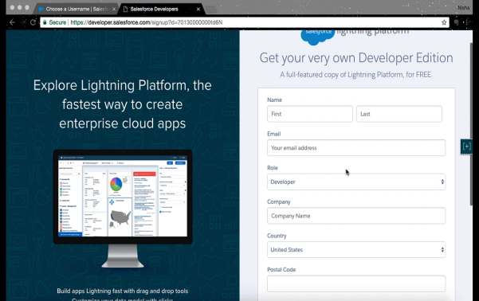

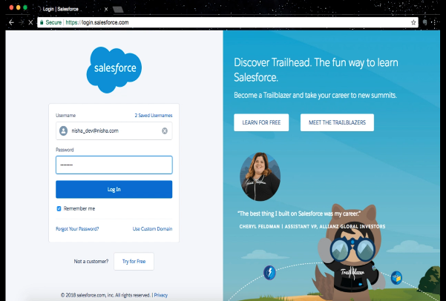

1. **Click on “Setup”.**

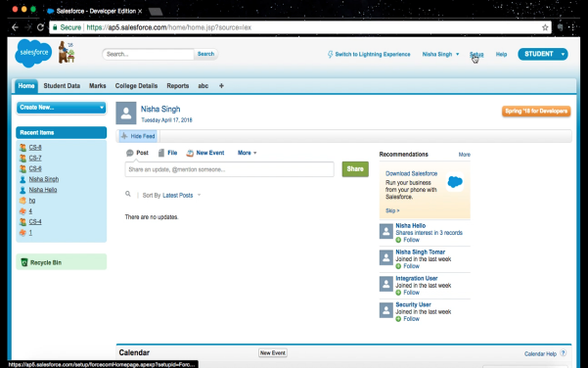

1. **In the “Build” menu on left, to create an app, click on “Create”, then click on “App”.**

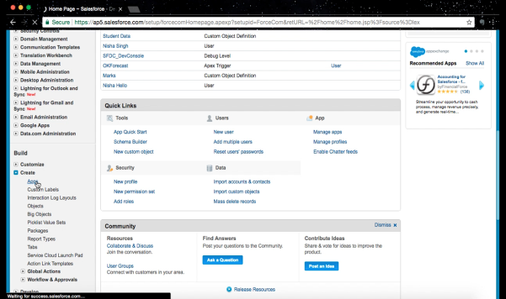

1. **Click on “New” Button and choose “Custom app”.**

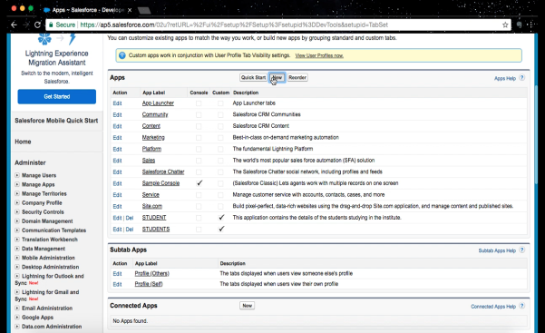

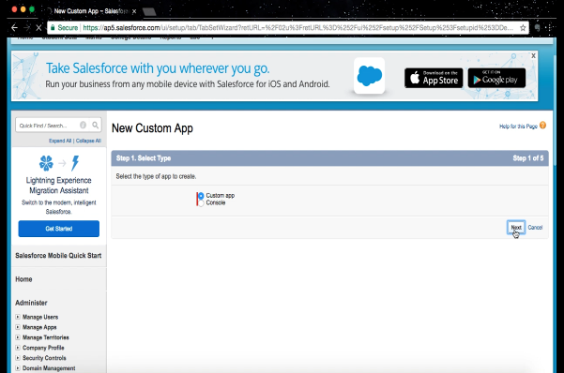

1. **Fill up the details and click on “Next” button.**

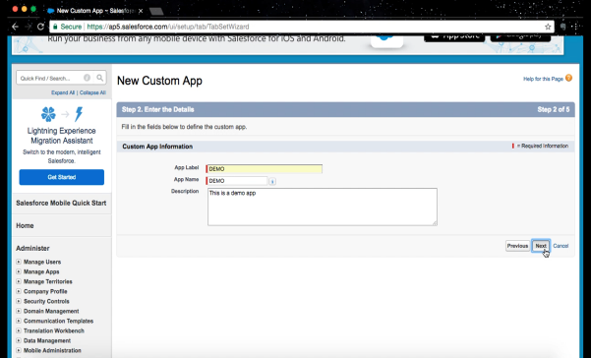

1. **Choose an app logo and then click on “Next”.**

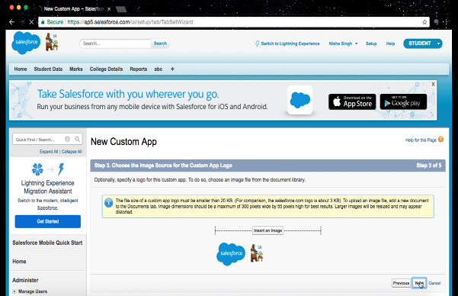

1. **Choose which profiles can view the app in AppExchange.**

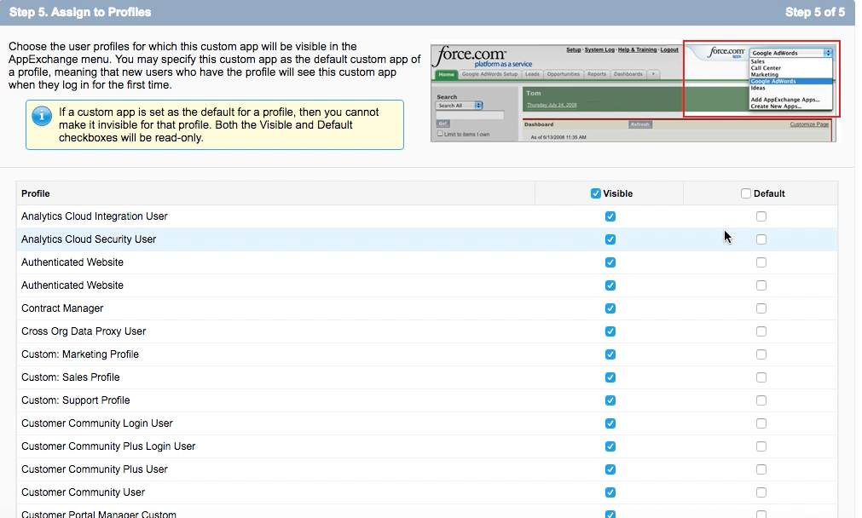

To create custom objects:

1. **Go to “Build” menu on left side and click on create then click on objects.**

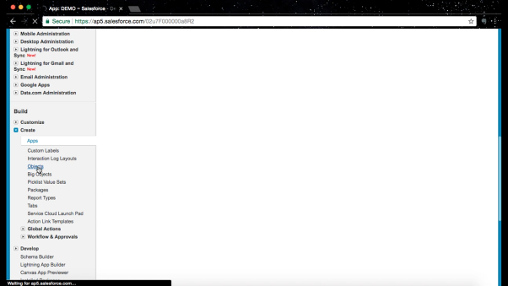

1. **Click on “New Custom Object”.**

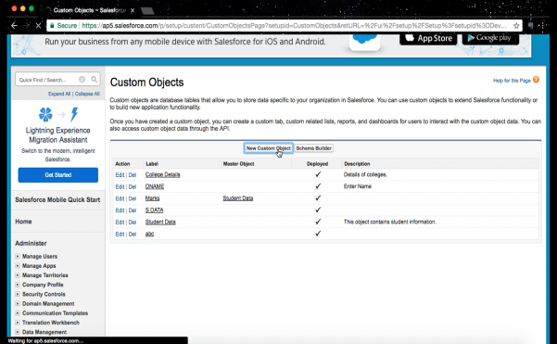

1. **Give the label of your object according to suggestion.**

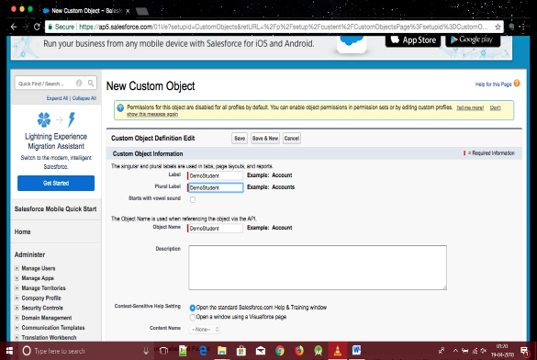

1. **In optional features tick one field “Allow Reports” so that the object is allowed to be included in reports. Then click on “Save”.**

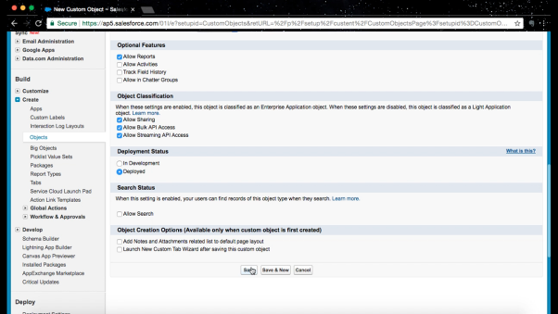

1. **You can see your Custom Object Definition Detail. API name ends in “__c” which indicates that it is custom.**

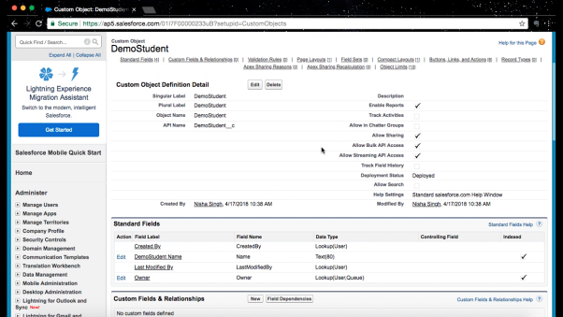

To create custom fields:

1. **In Custom Fields & Relationships click on “New” button.**

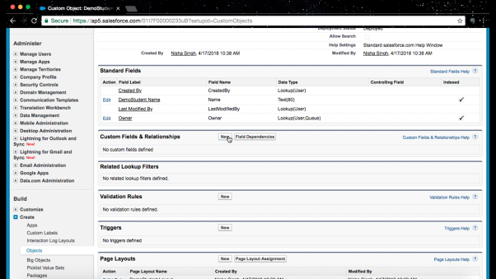

1. **Choose the data type of the field, there are various options.**

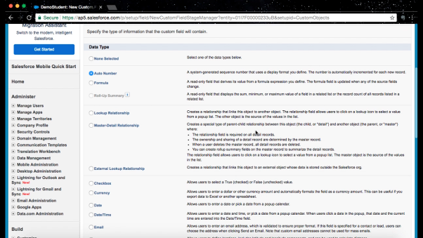

1. **Enter the Details of your field. You can also mention formats for text fields. Each field has such unique features. For example, you can specify number of digits after and before decimal for numeric fields. Click on “Next”.**

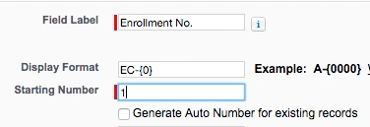

Another example, “Percent” type of field

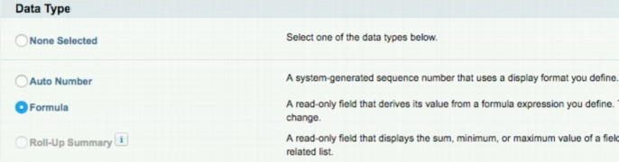

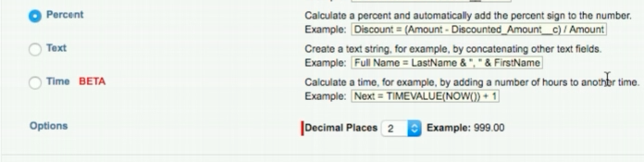

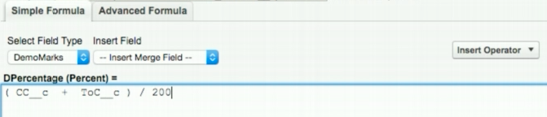

“Percentage’ field is filled automatically using the formula:

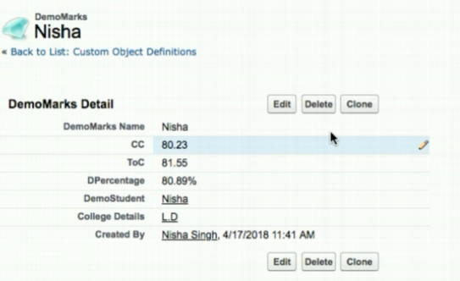

Another example, “Picklist” type of field. Enter the values of the list, rest of the steps are same as instructed above.

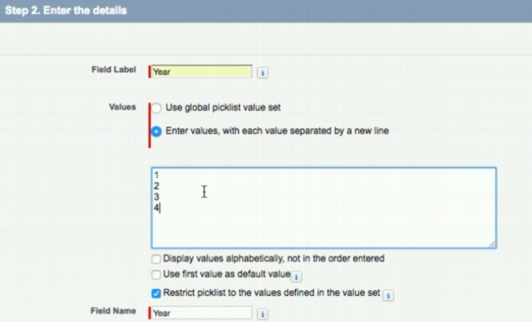

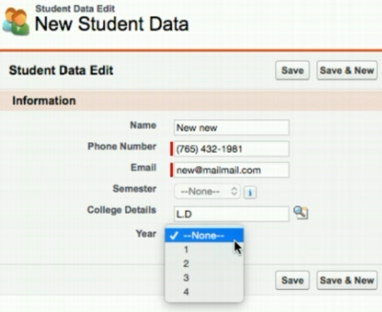

1. **You can establish your field-level security. And click on “Next button”.**

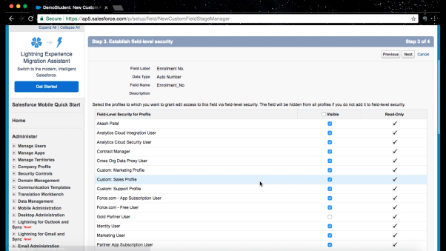

1. **You see your added custom fields which is specified at the end with “__c”**

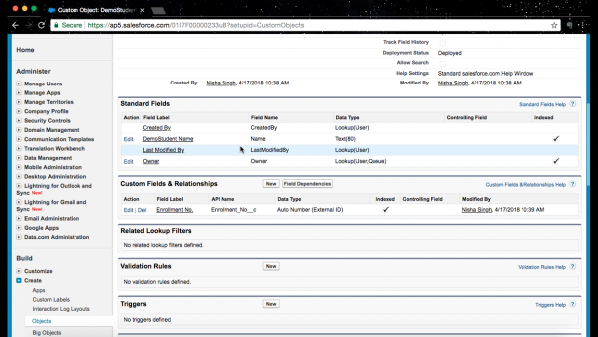

Master-Detail Relationship :

1. Choose “Master-Detail Relationship” as field’s data type.

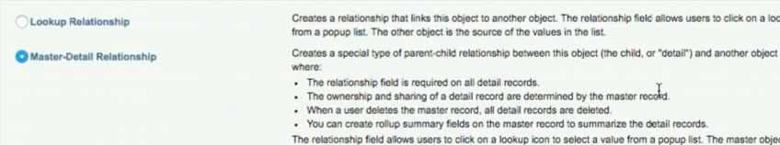

2. Choose the parent object.

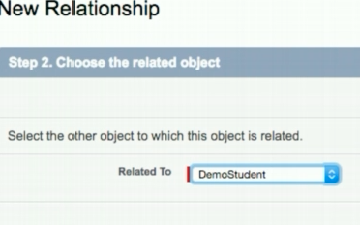

1. Fill field details and then click next on the next 3 steps.

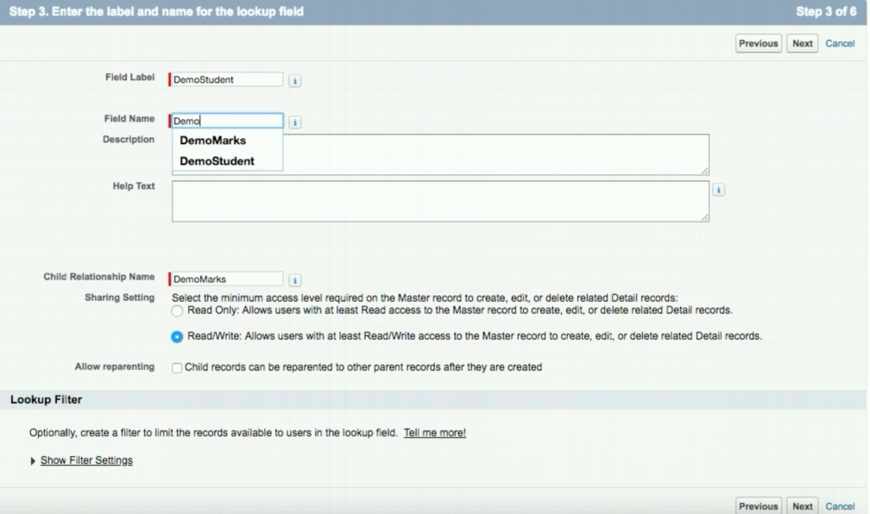

Lookup Relationship :

1. Choose “Lookup Relationship” as field’s data type.

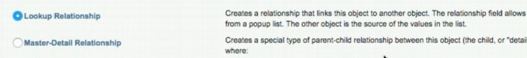

2. Choose the related object. Next, follow the same steps as in Master-Detail Relationship.

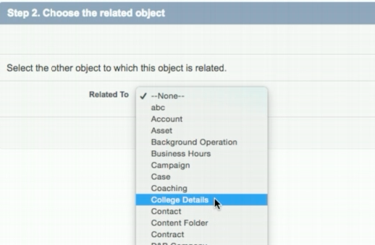

This is how lookup relationship works, it shows you a list to choose from:

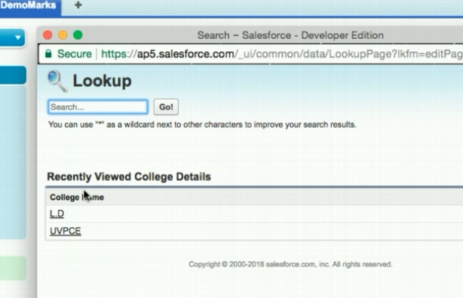

To customize tabs:

**1. Setup -> Create -> Tabs -> New**

**Fill details and click “Next” on the next 2 steps.**

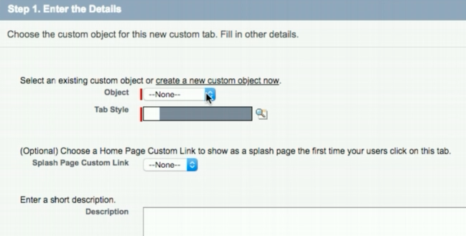

**2. You can also choose the tabs out of the available tabs to add to your app. You can also remove some.**

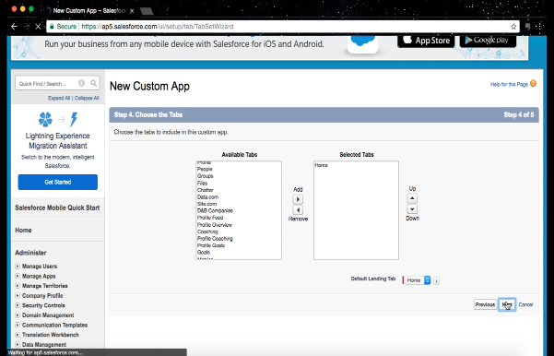

**3. Choose which fields to add to your tab by clicking on tab -> Create New View**

**(Click on “Edit” to edit a view you created.**

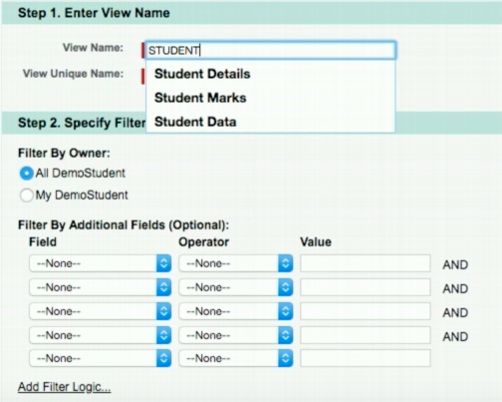

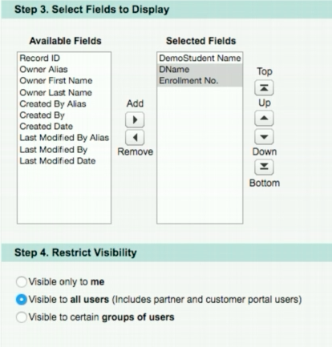

To view the schema builder:

1. Setup -> Build -> Schema Builder

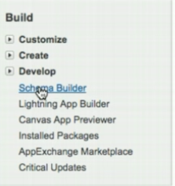

1. You can choose the object that you want to view in the schema builder on the left.

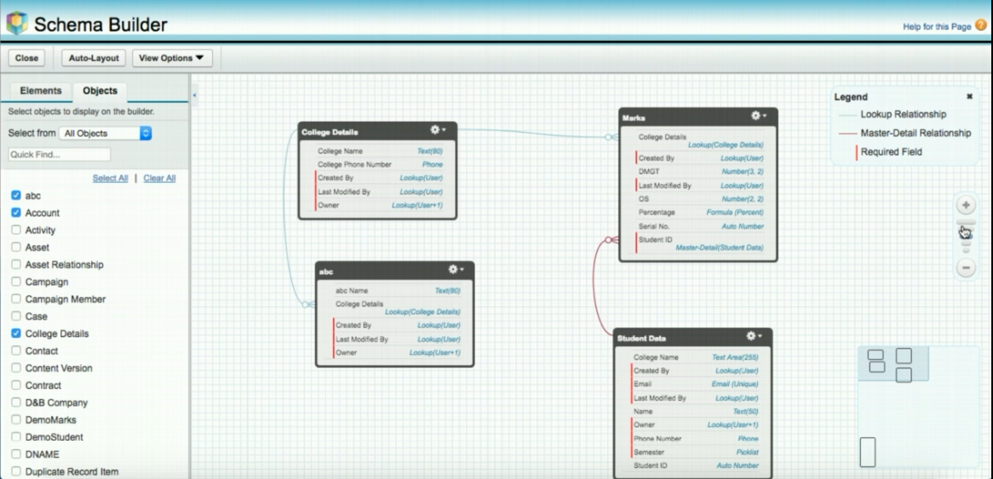

Profiles and their Users:

1. Setup -> Manage Users -> Profiles -> New Profile -> Profile created

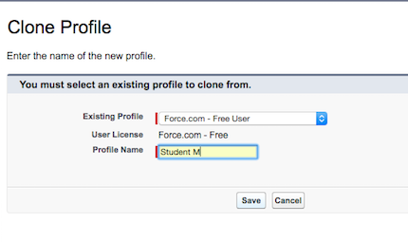

1. You can edit permissions by Setup -> Manage Users -> Profiles -> Click a profile -> Edit

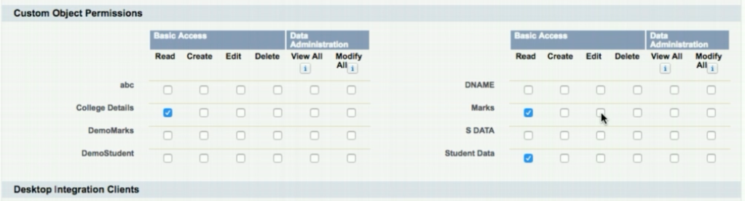

3. Setup -> Manage Users -> Users -> New User -> Profile created

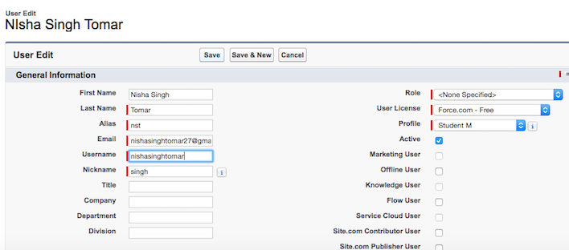

How to create reports:

1. Click on “+” in menu bad and customize the tabs as instructed above and add “Reports” tab.

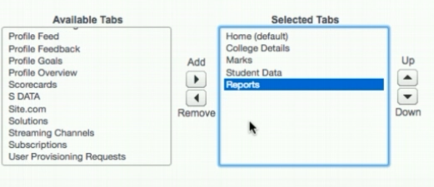

1. Click on “Report” tab -> New Report

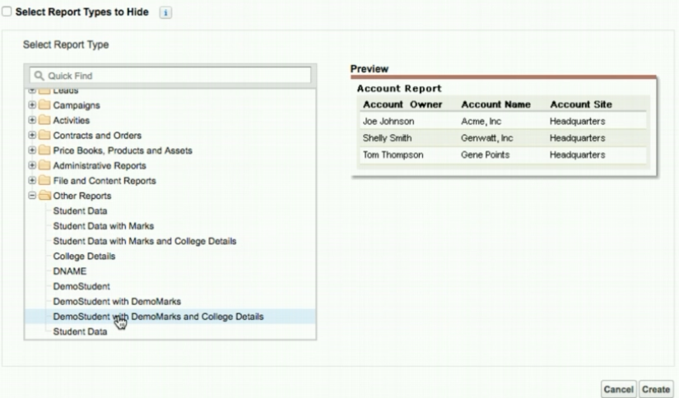

3. Fields in the report are displayed.

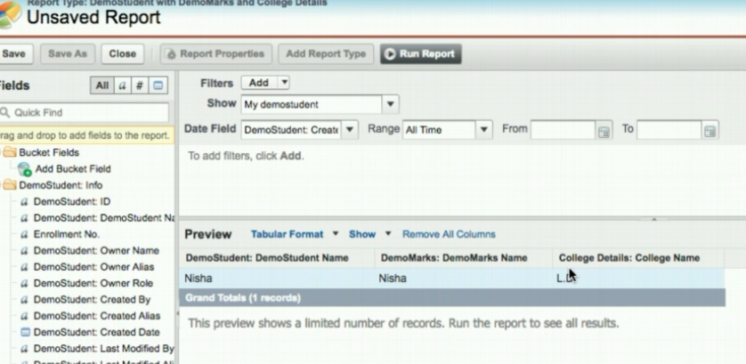

4. Click on “Run Report”. Report is displayed.

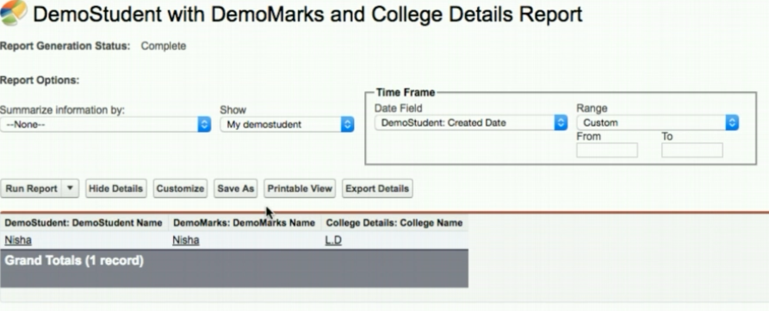

5. Click on “Save As”, add details and then click on “Save”.

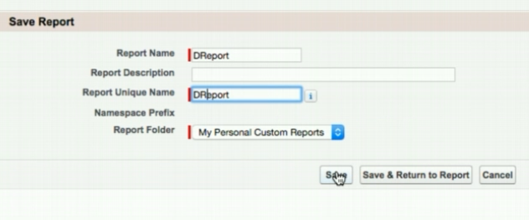

To create Field Dependencies:

1. Setup -> Create -> Objects -> Click on an object -> Click on “Field Dependencies” -> New

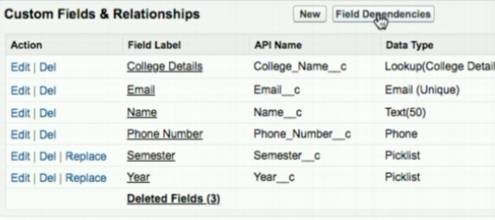

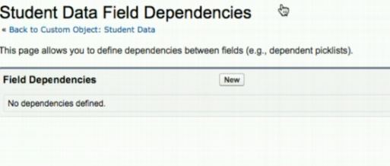

2. Choose Controlling and Dependent field and click on “Continue”.

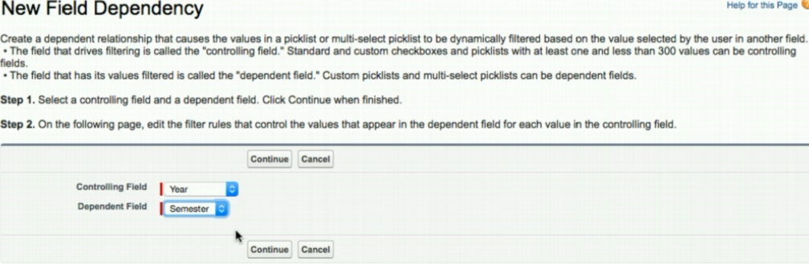

3. Include and exclude values from dependent field by clicking on them and then clicking “Include Values” or “Exclude Values”. And then click on “Save”.

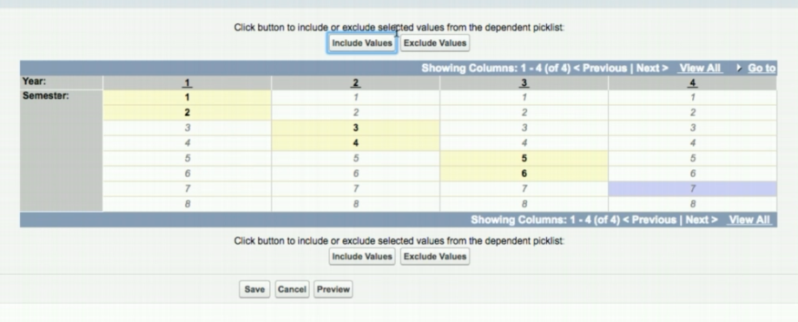

4. Go to the tab of the created field dependency and click on “New”. You can see that you can’t choose the dependent list without having a value in the controlling field.

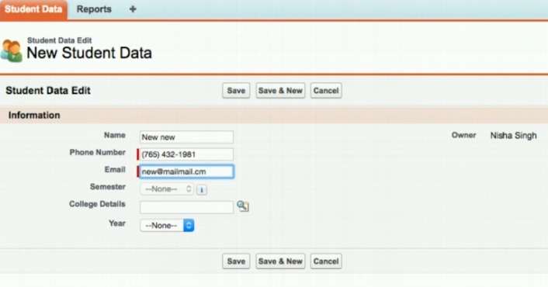

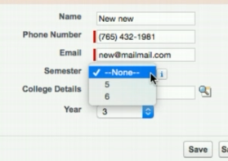

To create Triggers:

1. Click on account name on top right -> Developer Console

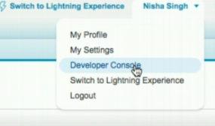

2. File -> New -> Trigger -> Apex Trigger -> Name it -> Choose object that trigger works on.

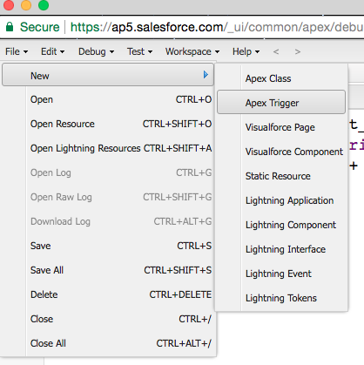

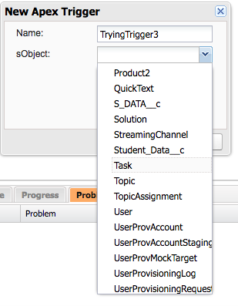

3. Write the code of the trigger. The example below adds “+91” to every phone number added in Student_Data__c object.

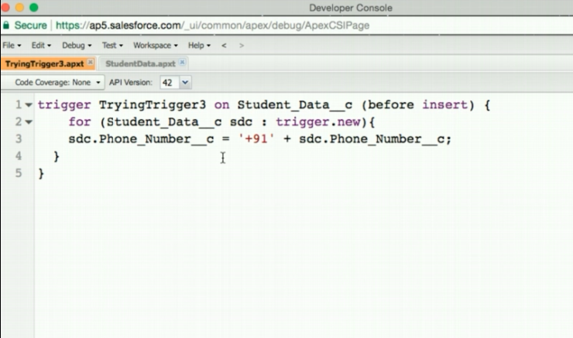

Enter new data in Student Data :

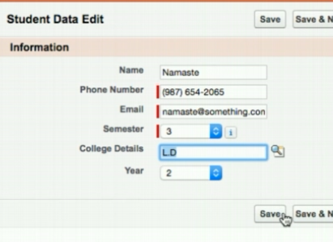

This is how it gets stored :

